Make sure you have Python installed on your computer  
  
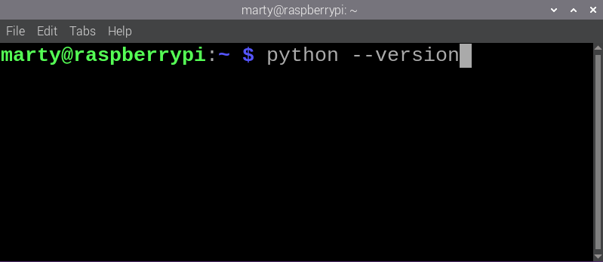  
  
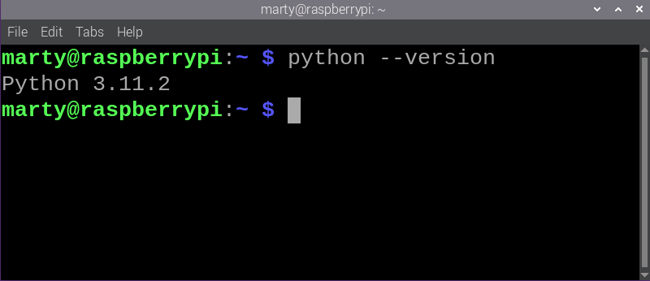  
  
If not install it <https://www.python.org/downloads/>   
  
 Open Microsoft VS code make sure Python extensions are added.  
  
Create a new project folder

Create a Python document and call it **led.py**, add the following code and Save

from gpiozero import LED

from time import sleep

# Initialize an LED connected to GPIO pin 17 using the GPIO Zero library.

led = LED(17)

while True:

# Turn on the LED and print a message to the console.

led.on()

print('LED ON')

# Wait for 0.5 seconds with the LED on.

sleep(0.5)

# Turn off the LED and print a message to the console.

led.off()

print('LED OFF')

# Wait for 0.5 seconds with the LED off.

sleep(0.5)

We will come back to the code later we now need to set up the breadboard  
  
You will need the following:

Raspberry Pi

GPIO Extension Board with cable to connect to Pi  
Breadboard

2x jumper cables  
1x LED light  
220 Resistor